**Name:** Jayanta Barman UID: 18mca8139

**Q)Create a web application based on .NET framework/Android(Based on Specialization Opted by student) App based and control multiple electrical device.**

**=>**

Circuit diagram:

Attach pin to raspberry pi according to diagram

Pin no. 32-RL1

Pin no. 36-RL2

Pin no. 38-RL3

Pin no. 40-RL14

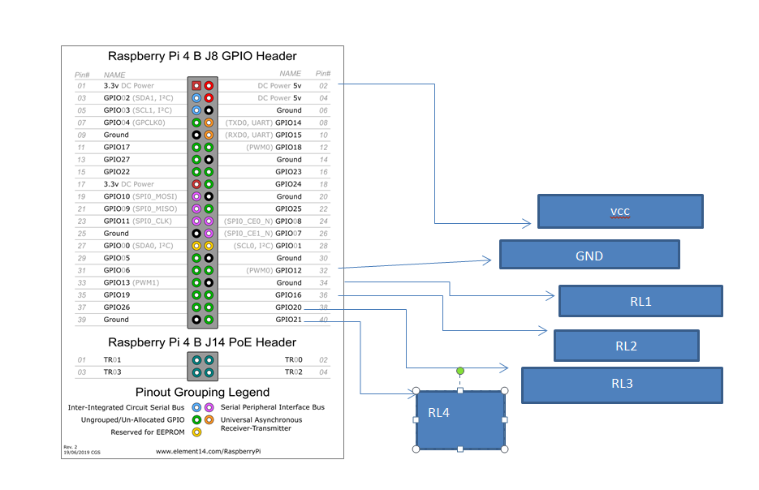

**Python code:**

Import RPi.GPIO as GPIO

from firebase import firebase

GPIO.setmode(GPIO.BOARD)

GPIO.setup(32,GPIO.OUT)

GPIO.setup(36,GPIO.OUT)

GPIO.setup(38,GPIO.OUT)

GPIO.setup(40,GPIO.OUT)

firebase =firebase.FirebaseApplication('https://raspiberrypi-18mca8142.firebaseio.com/', None)

result = firebase.get('/dh11', None)

while(True):

if(result[‘rl1’]==1):

GPIO.output(32,GPIO.HIGH)

else:

GPIO.output(32,GPIO.LOW)

#RL2

if(result[‘rl2’]==1):

GPIO.output(36,GPIO.HIGH)

else:

GPIO.output(36,GPIO.LOW)

#RL3

if(result[‘rl3’]==1):

GPIO.output(38,GPIO.HIGH)

else:

GPIO.output(38,GPIO.LOW)

#RL4

if(result[‘rl4’]==1):

GPIO.output(40,GPIO.HIGH)

else:

GPIO.output(40,GPIO.LOW)

**DATABASE DIAGRAM:**

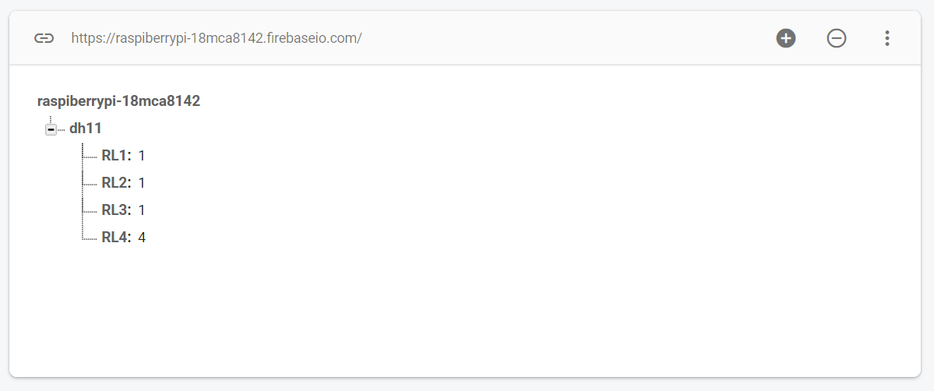

**ANDROID CODE**

**Now we are going to make application in android studio:**

**Xml code:**

*<?***xml version="1.0" encoding="utf-8"***?>*<**LinearLayoutxmlns:android="http://schemas.android.com/apk/res/android"  
xmlns:app="http://schemas.android.com/apk/res-auto"  
xmlns:tools="http://schemas.android.com/tools"  
android:layout_width="match_parent"  
android:layout_height="match_parent"  
tools:context=".MainActivity"  
android:orientation="vertical"**>  
  
  
<**Switch  
android:id="@+id/RL1"  
android:layout_width="match_parent"  
android:layout_height="wrap_content"  
android:text="RL1"** />  
<**Switch  
android:id="@+id/RL2"  
android:layout_width="match_parent"  
android:layout_height="wrap_content"  
android:text="RL2"** />  
<**Switch  
android:id="@+id/RL3"  
android:layout_width="match_parent"  
android:layout_height="wrap_content"  
android:text="RL3"** />  
<**Switch  
android:id="@+id/RL4"  
android:layout_width="match_parent"  
android:layout_height="wrap_content"  
android:text="RL4"** />  
  
<**TextView  
android:layout_width="match_parent"  
android:layout_height="100dp"  
android:text="rajeevsingh 18mca8142"**/>  
</**LinearLayout**>

**Mainactivity.java**

**package** com.example.cu_iot_assignment;  
  
**import** androidx.appcompat.app.AppCompatActivity;  
  
**import** android.os.Bundle;  
**import** android.view.View;  
**import** android.widget.Switch;  
  
**import** com.google.firebase.database.DatabaseReference;  
**import** com.google.firebase.database.FirebaseDatabase;  
  
**public class** MainActivity**extends** AppCompatActivity {  
 Switch **rl1**,**rl2**,**rl3**,**rl4**;  
  
**private** FirebaseDatabase**database**;  
**private** DatabaseReference**databaseReference**;  
@Override  
**protected void** onCreate(Bundle savedInstanceState) {  
**super**.onCreate(savedInstanceState);  
setContentView(R.layout.***activity_main***);  
**rl1**=findViewById(R.id.***RL1***);  
**rl2**=findViewById(R.id.***RL2***);  
**rl3**=findViewById(R.id.***RL3***);  
**rl4**=findViewById(R.id.***RL4***);  
**rl1**.setOnClickListener(**new** View.OnClickListener() {  
@Override  
**public void** onClick(View v) {  
**database** = FirebaseDatabase.*getInstance*();  
**databaseReference**= **database**.getReference(**"dh11"**);  
**if**(**rl1**.isChecked()) {  
  
**databaseReference**.child(**"RL1"**).setValue(1);  
 }  
**else**{  
**databaseReference**.child(**"RL1"**).setValue(0);  
 }  
  
 }  
 });  
**rl2**.setOnClickListener(**new** View.OnClickListener() {  
@Override  
**public void** onClick(View v) {  
**database** = FirebaseDatabase.*getInstance*();  
**databaseReference**= **database**.getReference(**"dh11"**);  
**if**(**rl1**.isChecked()) {  
  
**databaseReference**.child(**"RL2"**).setValue(1);  
 }  
**else**{  
**databaseReference**.child(**"RL2"**).setValue(0);  
 }  
  
 }  
 });  
**rl3**.setOnClickListener(**new** View.OnClickListener() {  
@Override  
**public void** onClick(View v) {  
**database** = FirebaseDatabase.*getInstance*();  
**databaseReference**= **database**.getReference(**"dh11"**);  
**if**(**rl1**.isChecked()) {  
  
**databaseReference**.child(**"RL3"**).setValue(1);  
 }  
**else**{  
**databaseReference**.child(**"RL3"**).setValue(0);  
 }  
  
 }  
 });  
**rl4**.setOnClickListener(**new** View.OnClickListener() {  
@Override  
**public void** onClick(View v) {  
**database** = FirebaseDatabase.*getInstance*();  
**databaseReference**= **database**.getReference(**"dh11"**);  
**if**(**rl1**.isChecked()) {  
  
**databaseReference**.child(**"RL4"**).setValue(1);  
 }  
**else**{  
**databaseReference**.child(**"RL4"**).setValue(0);  
 }  
  
 }  
 });  
 }  
}

**Diagram:**

